**Geography**

Use maps, atlases and satellite images to locate countries and describe features studied.

Use maps and atlases to build knowledge of the UK and wider world. Locate the counties and cities and describe their human and physical characteristics.

Describe and understand key aspects of human geography, including: types of settlement and land use, economic activity including trade links and the distribution of natural resources.

**History**

Learn about Britain’s settlement by Anglo-Saxons and Scots.

Learn about the Viking and Anglo-Saxon struggle for the Kingdom of England.

Select, organise, summarise and present relevant information, from a wide range of sources, about Anglo-Saxon and Viking civilisation.

.

Traders and Raiders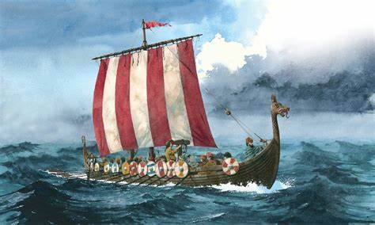

**Music**

Learn to sing songs and create music, inspired by the Gods and Goddesses of Viking Mythology.

Identify Viking musical instruments by recognising the sounds they make.

Listen and compare Viking inspired music using appropriate musical vocabulary.

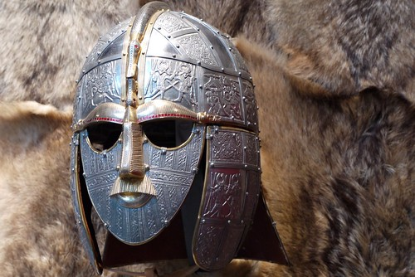

**Design Technology**

Create a model of an Anglo-Saxon home.

Investigate Saxon weaponry, considering the damage that the weapons could inflict. Then choose suitable materials to make a weapon.

Taste and enjoy food typically enjoyed at a Viking celebration.

**Art**

Improve mastery of art and design and sculpture with a range of materials

Find out about great artists, architects and designers in history.