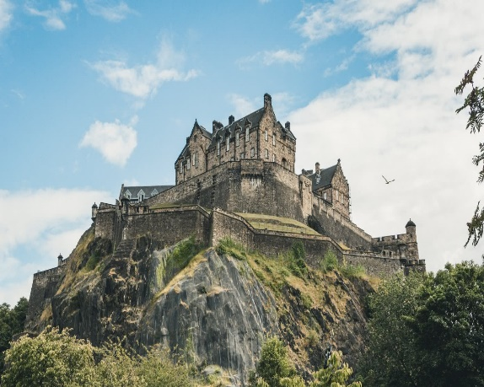

**Art**

Improve fine art skills through precise brush strokes.

Use clay to model castles.

Use a range of mediums to recreate a medieval castle.

Towers, Tunnels and Turrets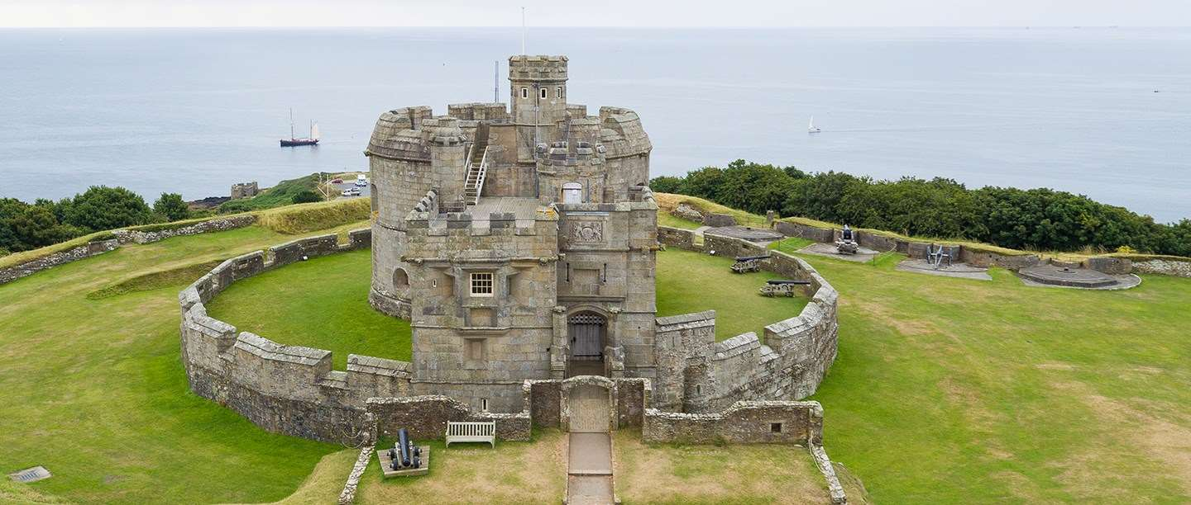s

**Music**

Listen to medieval music, learn to sing and dance in medieval fashion.

Recreate medieval music, using instruments and singing.

**Geography**

Plot famous castles on a map of the UK.

Study the land features surrounding castles and their significance in helping to defend them.

Study the need for famous tunnels and towers across the world in relation to the landscape.

**History**

Learn all about the history of castles and their purpose across the UK.

Learn about the main figureheads associated with castles including William the Conquer and Henry VIII.

Learn about life in a medieval castle and the roles of people who lived there.

Learn about famous towers and tunnels across the world and their significance in today’s society.

.

**Design Technology**

Cook medieval food and eat it at a medieval style banquet.

Design your dream castle, using knowledge of castle features and materials.

Investigate and recreate tunnels and towers, using a range of materials to determine which is the most suitable and why.