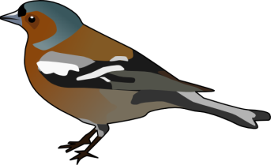
Chaffinch Class Newsletter
September 2019
Dear Parent/Carers,
Welcome to Chaffinch Class! I hope you have all had a lovely summer and the children are as excited for the new term as I am. The curriculum map for this term is on our class page. Our topic is ‘Bright Lights, Big City’ and we will begin this by enjoying a special afternoon tea for the Queen. The topic will involve us developing our Geography skills. We will make clear links to this topic in all subject areas, ensuring the National Curriculum expectations for Year 1 are being met. If you have any concerns please do not hesitate to speak to me.
PE
PE days in Chaffinch Class will be on a Monday and Tuesday - please can you ensure your child’s PE kit is in school on these days. It is a good idea to leave your child’s PE kit in school across the half-term - it will be sent home at the end of every half term. The children will be required to have a pair of trainers and wellies in school every day for participation in the Golden Mile and outdoor learning. Children with long hair are required to have it tied back and earrings must be removed during PE sessions. Please could you ensure all belongings are named to help prevent clothing becoming misplaced. We will be encouraging the children to take ownership of their own things to support their independence.
Reading
We will aim to hear children read 3 times a week through group guided reading sessions. The children will have daily phonics lessons to support their decoding and spelling of unfamiliar words. Please could you ensure you read regularly with your children at home and use their reading records to communicate their progress with us - these will be checked regularly.
Homework
Children will be sent home weekly spellings – either the common exception words the children are required to know or the phonic sounds they have been learning that week. I have attached a home learning grid too, with links to our topic ‘Bright Lights, Big City’. Please could the children aim to complete at least three of these tasks. All homework will be handed out on a Friday - please ensure it is returned by the following Thursday, so that I can give feedback to the children.
Class Dojo
Class Dojo is the reward chart system we will be using. This will allow the children to earn valuable points when demonstrating excellent behaviour, being kind to others, producing some wonderful work or following our school values. This is an amazing tool as it allows you to see how the children are progressing and to celebrate their successes. Points can also be taken away for undesirable behaviour - when this is done we will ensure the children understand why this has happened.
Food Allergies/Medicine
Please ensure the school knows of any food allergies that your child has. Our school first aiders are able to administer prescribed medication from a doctor to the children - please ensure that this is given to the appropriate adult and the correct forms are filled in at the office.
Finally please feel free to speak to me if you have any concerns about anything.

